# Software Requirements

Version 1.0.1, last updated by Sail at 2020-09-19

# Software Requirements Specification (SRS)

Revision History:

|  |  |  |
| --- | --- | --- |
| Date | Author | Description |
| 2020-09-19 | Sail | Writing. |
|  |  |  |
|  |  |  |
|  |  |  |

Contents

Software Requirements 1

Software Requirements Specification (SRS) 1

1.  Introduction 3

1.1    Intended Audience and Purpose 3

2.  Concept of Operations 3

2.1    System Context 3

2.2    System capabilities 4

3.  Use Cases 4

3.1 System Inputs and Outputs 6

3.1.1 Inputs 6

3.1.2 Outputs 6

4   Quality Requirements 7

5.    Fundamental Assumptions 7

6.    Expected Changes 7

## 1.  Introduction

### 1.1    Intended Audience and Purpose

This document is intended to provide information guiding the installation and development process, ensuring that all system requirements are met.

Estimated Gantt Graph:

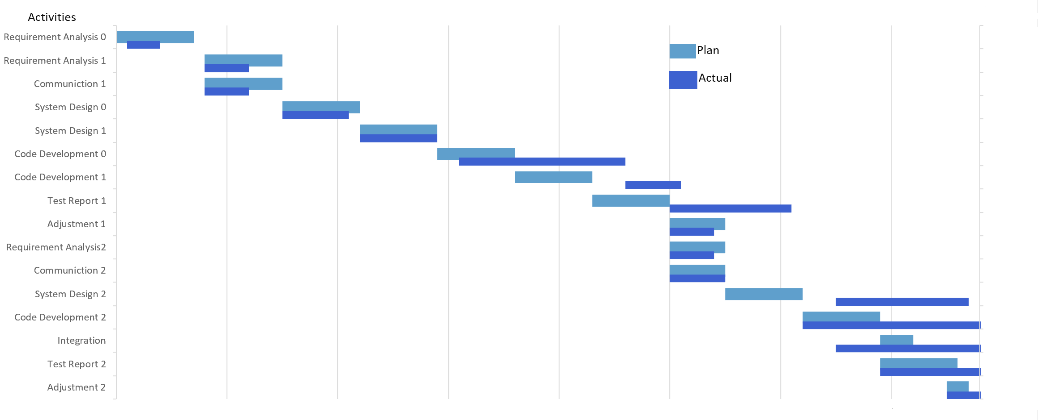

## 2.  Concept of Operations

The aim is to write an excellent artificial intelligence algorithm for processing images of scoliosis. This algorithm will read a picture and output the analysis results. Other programs calling this program should ensure the format and quantity of input content. At the same time, they should also meet the interface provided by this program.

### 2.1    System Context

**System Requirements:**

Requires a system with a GUI display because all of the operations are performed through a GUI. The application is in Android so users must have a smart phone with Android System.

Android:

* Android 4 or higher
* SDK: API 4 (Minimum)
* RAM: 256M (Minimum)
* Disk space: 256M (Minimum, for data and others)
* Processor: Qualcomm Snapdragon 410 (Minimum)

### 2.2    System capabilities

Call this program, one can get the processing results of the picture. This program will give guidance information on whether the picture belongs to scoliosis, the type of scoliosis, the angle of scoliosis, and other useful information.

## 3.  Use Cases

1、Users upload X-ray pictures via mobile phones.

2、Users view the analysis results.

### 3.1 System Inputs and Outputs

### 3.1.1 Inputs

X-ray pictures

### 3.1.2 Outputs

X-ray pictures analysis results.

## 4   Quality Requirements

The program should Adapt to the interface provided by the server

Provide users with good and easy-to-use interaction

The program needs to show the results of the server-side calculations to the user well, and the requirements are simple and easy to understand

## 5.    Fundamental Assumptions

The user is familiar with the normal interaction logic of Android.

## 6.    Expected Changes

Future Platforms:

IOS system  
performance requirements

Languages